XML and XHTML
Prepared: TrangNTT
Lab 9. XML and XHTML 1
9.1. XML document 2
9.2. MathML 2
9.3. KML 2
9.4. SVG 2
9.5. Exercise 1: HTML, XHTML & XML 3
9.6. Exercise 2: MVC Model Framework using XML 3
9.7. Exercise 3: XML Programming 4

XML document
Create your own XML document for Student information

MathML
Check your firefox is equal or more than 3.6.
Write the following MathML to get this expression: 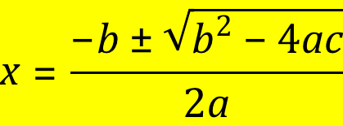
<mrow xmlns=“&mathml;”>
<mi>x</mi><mo>=</mo>
<mfrac>
<mrow>
<mrow><mo>-</mo><mi>b</mi></mrow>
<mo>&PlusMinus;</mo>
<msqrt><mrow>
<msup><mi>b</mi><mn>2</mn></msup>
<mo>-</mo>
<mrow><mn>4</mn><mi>a</mi><mi>c</mi></mrow>
</mrow></msqrt>
</mrow>
<mrow><mn>2</mn><mi>a</mi></mrow>
</mfrac>
</mrow>

KML
- Find coordinates of your home at Google Map
- right click then click “What’s here” at the point your home
- Rewrite sample file’s placemark to point your home
- Open the KML file with Google Earth/Map

SVG
Draw Japanese Flag using SVG:
<?xml version="1.0"?>

<!DOCTYPE svg PUBLIC "-//W3C//DTD SVG 1.1//EN"
"http://www.w3.org/Graphics/SVG/1.1/DTD/svg11.dtd">

<svg xmlns="http://www.w3.org/2000/svg"
width="200" height="200">
<circle cx="100" cy="100" r="50" stroke="black"
stroke-width="5" fill="red" />
</svg>

Exercise 1: HTML, XHTML & XML

HTML 4.01 Strict
- Add DOCTYPE for HTML4.01 Strict into HTML files created previous classes (profile.html).
- Validate them by the Markup Validation Service
- Correct them until they have no errors.

XHTML 1.0 Strict
- Copy files of Exercise 1. and change DOCTYPE to XHTML1.0 Strict
- Fix them to be suitable for XHTML1.0 Strict
- Validate them by the Markup Validation Service
- Confirm differences between HTML and XHTML
- Correct them until they have no errors as well as Exercise 1.

Well-formed XML
Check and compare DTD, XML Schema, Relax NG and other schema languages for XML

SVG
Draw the national flag of Vietnam
- Red rectangular – width:height = 3:2
- Yellow star
Hint: drawing star with polygon element.

XML Application
- Search and find XML Applications
  - (Hint?: XUL, EPUB, ATOM, Android SDK, XBRL…)
- Explain them from the following viewpoints
  - Application domain, its purpose, function
  - Standard defining organization of the application
    - (ISO? W3C? Moziila.org? Google? Microsoft?)
- Explain how to use some characteristic element and attributes (e.g. <circle> of SVG)
- Describe some short example documents of the application and write comment on those documents.

Exercise 2: MVC Model Framework using XML
There is a MVC framework for PHP which rose by Tony Marston.

Please have a careful look at http://www.tonymarston.net/php-mysql/model-view-controller.html, read and follow his proposed framework to develop a use case for user management (including: add, delete, update and search) for administrators.

His main idea is in the following figures:

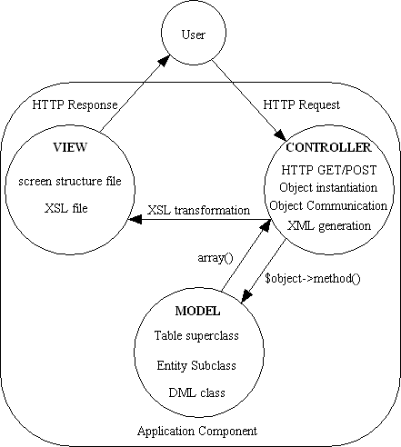

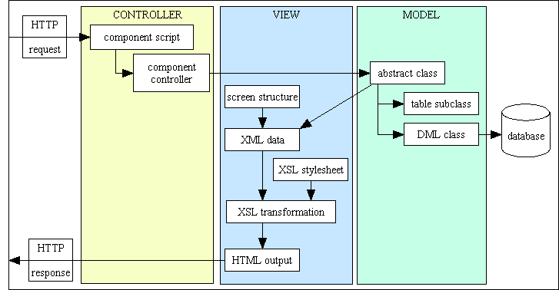

Exercise 3: XML Programming
Read the following guide to practice XML Programming.
Unless you've been hiding in a cave for the last few years, you've heard about XML - it's the toolkit that more and more Web publishers are switching to for content markup. You may even have seen an XML document in action, complete with user-defined tags and markup, and you might have wondered how on earth one converts that tangled mess of code into human-readable content.
The answer is, not easily.
While PHP has included support for the two standard methods of parsing (read: making sense of) XML - SAX and DOM - since version 4.0, the complexity and inherent geekiness of these methods often turned off all but the most dedicated XML developers. All that has changed, however, with PHP 5.0, which introduces a brand-spanking-new XML extension named SimpleXML that takes all (and I do mean all) the pain out of processing XML documents. Keep reading, and find out how.

The Bad Old Days
In order to understand why SimpleXML is so cool, a brief history lesson is in order.
In the days before SimpleXML, there were two ways of processing XML documents. The first, SAX or the Simple API for XML, involved traversing an XML document and calling specific functions as the parser encountered different types of tags. For example, you might have called one function to process a starting tag, another function to process an ending tag, and a third function to process the data between them. The second, DOM or the Document Object Model, involved creating a tree representation of the XML document in memory, and then using tree-traversal methods to navigate it. Once a particular node of the tree was reached, the corresponding content could be retrieved and used.
Neither of these two approaches was particularly user-friendly: SAX required the developer to custom-craft event handlers for each type of element encountered in an XML file, while the DOM approach used an object-oriented paradigm which tended to throw developers off, in addition to being memory-intensive and thus inefficient with large XML documents. In the larger context also, PHP 4 used a number of different backend libraries for each of its different XML extensions, leading to inconsistency in the way different XML extensions worked and thus creating interoperability concerns (as well as a fair amount of confusion for developers).
With PHP 5.0, a concerted effort was made to fix this problem, by adopting the libxml2 library (http://www.xmlsoft.org/) as the standard library for all XML extensions and by getting the various XML extensions to operate more consistently. The biggest change in the PHP 5 XML pantheon, though, is the SimpleXML extension developed by Sterling Hughes, Rob Richards and Marcus Börger, which attempts to make parsing XML documents significantly more user-friendly than it was in PHP 4.
SimpleXML works by converting an XML document into an object, and then turning the elements within that document into object properties which can be accessed using standard object notation. This makes it easy to drill down to an element at any level of the XML hierarchy to access its content. Repeated elements at the same level of the document tree are represented as arrays, while custom element collections can be created using XPath location paths (of which, more later); these collections can then be processed using PHP's standard loop constructs. Accessing element attributes is as simple as accessing the keys of an associative array - there's nothing new to learn, and no special code to write.
In order to use SimpleXML and PHP together, your PHP build must include support for SimpleXML. This support is enabled by default in both the UNIX and Windows versions of PHP 5. Read more about this at http://www.php.net/manual/en/ref.simplexml.php. If you're a PHP 4 user, you're out of luck - SimpleXML is only available for PHP 5.

Petting Zoo
To see how SimpleXML works, consider the following XML file:
<?xml version="1.0"?>
<pet>
<name>Polly Parrot</name>
<age>3</age>
<species>parrot</species>
<parents>
<mother>Pia Parrot</mother>
<father>Peter Parrot</father>
</parents>
</pet>
Now, you need a way to get to the content enclosed between the <name>, <age>, <species> and <parents> elements. With SimpleXML, it's a snap:
<?php
// set name of XML file
$file = "pet.xml";
// load file
$xml = simplexml_load_file($file) or die ("Unable to load XML file!");
// access XML data
echo "Name: " . $xml->name . "\n";
echo "Age: " . $xml->age . "\n";
echo "Species: " . $xml->species . "\n";
echo "Parents: " . $xml->parents->mother . " and " . $xml->parents->father . "\n";
?>
The action begins with the simplexml_load_file() function, which accepts the path and name of the XML file to be parsed. The result of parsing the file is a PHP object, whose properties correspond to the elements under the root element. The character data within an element can then be accessed using standard object->property notation, beginning with the root element and moving down the hierarchical path of the document.
Just as you can read, so also can you write. SimpleXML makes it easy to alter the contents of a particular XML element - simply assign a new value to the corresponding object property. Here's an example:
<?php
// set name of XML file
$file = "pet.xml";
// load file
$xml = simplexml_load_file($file) or die ("Unable to load XML file!");
// modify XML data
$xml->name = "Sammy Snail";
$xml->age = 4;
$xml->species = "snail";
$xml->parents->mother = "Sue Snail";
$xml->parents->father = "Sid Snail";
// write new data to file
file_put_contents($file, $xml->asXML());
?>
Here, the original XML file is first read in, and then the character data enclosed within each element is altered by assigning new values to the corresponding object property. The asXML() method, typically used to dump the XML tree back out to the standard output device, is in this instance combined with the file_put_contents() function to overwrite the original XML document with the new data.

Sin City
Repeated elements at the same level of the XML hierarchy are represented as array elements, and can be accessed using numeric indices. To see how this works, consider the following XML file:
<?xml version="1.0"?>
<sins>
<sin>pride</sin>
<sin>envy</sin>
<sin>anger</sin>
<sin>greed</sin>
<sin>sloth</sin>
<sin>gluttony</sin>
<sin>lust</sin>
</sins>
Here's the PHP script that reads it and retrieves the data from it:
<?php
// set name of XML file
$file = "sins.xml";
// load file
$xml = simplexml_load_file($file) or die ("Unable to load XML file!");
// access each <sin>
echo $xml->sin[0] . "\n";
echo $xml->sin[1] . "\n";
echo $xml->sin[2] . "\n";
echo $xml->sin[3] . "\n";
echo $xml->sin[4] . "\n";
echo $xml->sin[5] . "\n";
echo $xml->sin[6] . "\n";
?>
If you'd prefer, you can even iterate over the collection with a foreach() loop, as in this next, equivalent listing:
<?php
// set name of XML file
$file = "sins.xml";
// load file
$xml = simplexml_load_file($file) or die ("Unable to load XML file!");
// iterate over <sin> element collection
foreach ($xml->sin as $sin) {
echo "$sin\n";
}
?>

The Shape of Things to Come
SimpleXML handles element attributes as transparently as it does elements and their content. Attribute-value pairs are represented as members of a PHP associative array, and can be accessed like regular array elements. To see how this works, take a look at this script:
<?php
// create XML string
$str = <<< XML
<?xml version="1.0"?>
<shapes>
<shape type="circle" radius="2" />
<shape type="rectangle" length="5" width="2" />
<shape type="square" length="7" />
</shapes>
XML;
// load string
$xml = simplexml_load_string($str) or die ("Unable to load XML string!");
// for each shape
// calculate area
foreach ($xml->shape as $shape) {
if ($shape['type'] == "circle") {
$area = pi() * $shape['radius'] * $shape['radius'];
}
elseif ($shape['type'] == "rectangle") {
$area = $shape['length'] * $shape['width'];
}
elseif ($shape['type'] == "square") {
$area = $shape['length'] * $shape['length'];
}
echo $area."\n";
}
?>
Unlike previous examples, which used an external XML file, this one creates the XML dynamically and loads it into SimpleXML with the simplexml_load_string() method. The XML is then parsed with a foreach() loop, and the area for each shape calculated on the basis of the value of each <shape> element's type attribute. The listing above demonstrates how attribute values can be accessed as keys of the attribute array associated with each element property.

X Marks The Spot
SimpleXML also supports custom element collections, through XPath location paths. For those of you new to XML, XPath is a standard addressing mechanism for an XML document, allowing developers to access collections of elements, attributes or text nodes within a document. Read more about XPath at http://www.w3.org/TR/xpath.html and http://www.melonfire.com/community/columns/trog/article.php?id=83.
To see how this works, consider the following XML document:
<?xml version="1.0"?>
<ingredients>
<item>
<desc>Boneless chicken breasts</desc>
<quantity>2</quantity>
</item>
<item>
<desc>Chopped onions</desc>
<quantity>2</quantity>
</item>
<item>
<desc>Ginger</desc>
<quantity>1</quantity>
</item>
<item>
<desc>Garlic</desc>
<quantity>1</quantity>
</item>
<item>
<desc>Red chili powder</desc>
<quantity>1</quantity>
</item>
<item>
<desc>Coriander seeds</desc>
<quantity>1</quantity>
</item>
<item>
<desc>Lime juice</desc>
<quantity>2</quantity>
</item>
</ingredients>
Now, let's suppose you want to print all the <desc> elements. You could do it by iterating over the array of <item> elements, as discussed earlier...or you could just create a custom collection of only the <desc> elements with the xpath() method, and iterate over that instead:
<?php
// set name of XML file
$file = "ingredients.xml";
// load file
$xml = simplexml_load_file($file) or die ("Unable to load XML file!");
// get all the <desc> elements and print
foreach ($xml->xpath('//desc') as $desc) {
echo "$desc\n";
}
?>
Using XPath, you can get even fancier than this - for example, by creating a collection of only those <desc> elements whose corresponding quantities are two or more.
<?php
// set name of XML file
$file = "ingredients.xml";
// load file
$xml = simplexml_load_file($file) or die ("Unable to load XML file!");
// get all the <desc> elements and print
foreach ($xml->xpath('//item[quantity > 1]/desc') as $desc) {
echo "$desc\n";
}
?>
Without XPath, accomplishing this would be far more complicated than the five lines of code above...try it for yourself and see!

An Evening At The Moulin Rouge
Now that you've seen what XPath can do, let's wrap this up with an example of how you might actually use it. Let's suppose you have a bunch of movie reviews marked up in XML, like this:
<?xml version="1.0"?>
<review id="57" category="2">
<title>Moulin Rouge</title>
<teaser>
Baz Luhrmann's over-the-top vision of Paris at the turn of the century
is witty, sexy...and completely unforgettable
</teaser>
<cast>
<person>Nicole Kidman</person>
<person>Ewan McGregor</person>
<person>John Leguizamo</person>
<person>Jim Broadbent</person>
<person>Richard Roxburgh</person>
</cast>
<director>Baz Luhrmann</director>
<duration>120</duration>
<genre>Romance/Comedy</genre>
<year>2001</year>
<body>
A stylishly spectacular extravaganza, Moulin Rouge is hard to
categorize; it is, at different times, a love story, a costume drama,
a musical, and a comedy. Director Baz Luhrmann (well-known for the
very hip William Shakespeare's Romeo + Juliet) has taken some simple
themes - love, jealousy and obsession - and done something completely
new and different with them by setting them to music.
</body>
<rating>5</rating>
</review>
Now, you want to display this review on your Web site. So, you need a PHP script to extract the data from this file and place it in the appropriate locations in an HTML template. With everything you've learned so far, this is a snap...as the code below illustrates:
<?php
// set name of XML file
// normally this would come through GET
// it's hard-wired here for simplicity
$file = "57.xml";
// load file
$xml = simplexml_load_file($file) or die ("Unable to load XML file!");
?>
<html>
<head><basefont face="Arial"></head>
<body>
<!-- title and year -->
<h1><?php echo $xml->title; ?> (<?php echo $xml->year; ?>)</h1>
<!-- slug -->
<h3><?php echo $xml->teaser; ?></h3>
<!-- review body -->
<?php echo $xml->body; ?>
<!-- director, cast, duration and rating -->
<p align="right"/>
<font size="-2">
Director: <b><?php echo $xml->director; ?></b>
<br />
Duration: <b><?php echo $xml->duration; ?> min</b>
<br />
Cast: <b><?php foreach ($xml->cast->person as $person) { echo "$person "; } ?></b>
<br />
Rating: <b><?php echo $xml->rating; ?></b>
</font>
</body>
</html>

